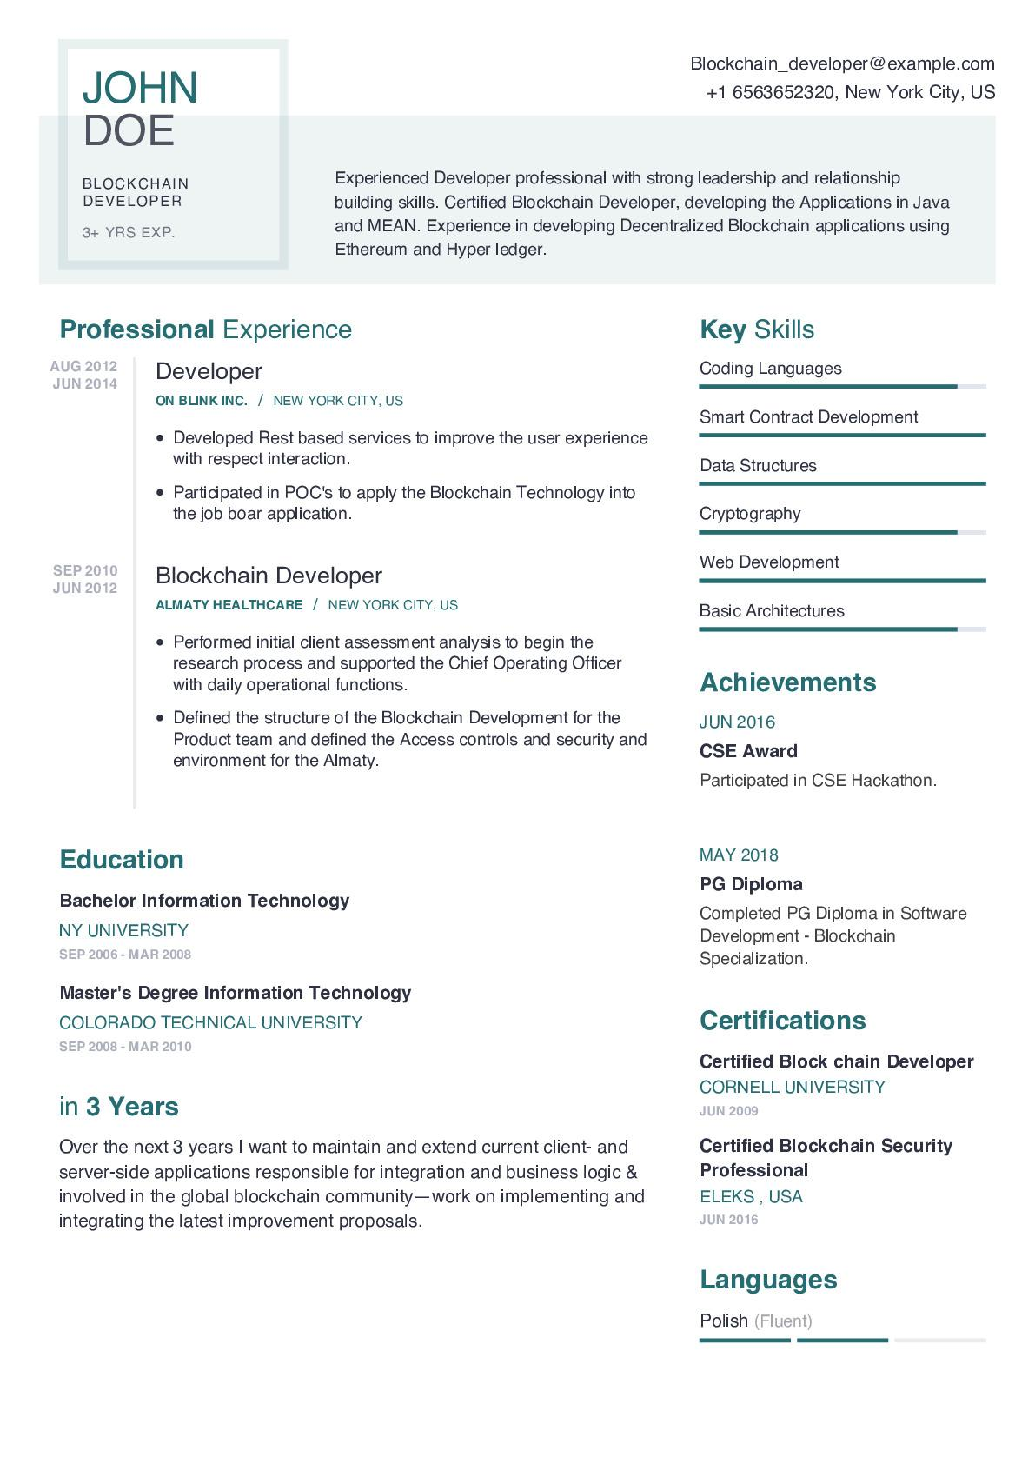
JOHN DOE
BLOCKCHAIN DEVELOPER
3+ YRS EXP.
Blockchain_developer@example.com
+1 6563652320, New York City, US
Experienced Developer professional with strong leadership and relationship building skills. Certified Blockchain Developer, developing the Applications in Java and MEAN. Experience in developing Decentralized Blockchain applications using Ethereum and Hyper ledger.
Professional Experience
AUG 2012
JUN 2014
SEP 2010
JUN 2012
Developer
ON BLINK INC. / NEW YORK CITY, US
• Developed Rest based services to improve the user experience with respect interaction.
• Participated in POC's to apply the Blockchain Technology into the job boar application.
Blockchain Developer
ALMATY HEALTHCARE / NEW YORK CITY, US
Performed initial client assessment analysis to begin the research process and supported the Chief Operating Officer with daily operational functions.
• Defined the structure of the Blockchain Development for the Product team and defined the Access controls and security and environment for the Almaty.
Key Skills Coding Languages
Smart Contract Development
Data Structures
Cryptography
Web Development
Basic Architectures
Achievements
JUN 2016
CSE Award
Participated in CSE Hackathon.
Education
Bachelor Information Technology
NY UNIVERSITY
SEP 2006 MAR 2008
Master's Degree Information Technology
COLORADO TECHNICAL UNIVERSITY SEP 2008-MAR 2010
in 3 Years
Over the next 3 years I want to maintain and extend current client- and server-side applications responsible for integration and business logic & involved in the global blockchain community-work on implementing and integrating the latest improvement proposals.
MAY 2018
PG Diploma
Completed PG Diploma in Software Development Blockchain Specialization.
Certifications
Certified Block chain Developer CORNELL UNIVERSITY
JUN 2009
Certified Blockchain Security Professional
ELEKS, USA
JUN 2016
Languages
Polish (Fluent)

